User's Guide:

Input Definitions Screen:

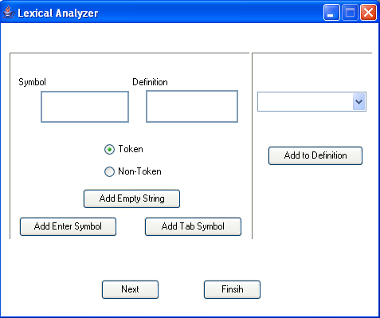

Fig. 3. Input Definition Screen

1 1
2
3 1
4
5
6
7
10
8
9
11

Fig. 4. Demonstrate each component

- Text area to add definition name.
- Text area to add the regular definition.
- Radio button selected if the definition is a recognized pattern
- Radio button selected if the definition is not a recognized pattern
- Button to add λ (Empty string) to the definition.
- Button to add Enter (New line) to the definition.
- Button to add Tab to the definition.
- Drop down list filled with the previous regular definitions the user can use it to select previous regular definition.
- Button to add the selected previous definition to the current definition.
- Button to add new definition.
- Button to finish entering the regular definitions.

To enter a new definition adds its name at symbol's area, if the definition consists of only a stream of terminals write these terminals at definition's area, press "Next", if you want to add another definition, or press "Finish", if it was the last definition.
Example:
To add definition
Function → Function
- Write Function at symbol's area
- Write Function at definition's area
- press "Next" or "Finish"

If the definition having OR, use CTRL + | to separate between ORed productions.
Example:
To add definition
Standard_type → integer | real
- Write Standard_type at symbol's area
- Write integer at definition's area
- Press CTRL + |
- Write real at definition's area
- press "Next" or "Finish"

If the definition having Closure, use CTRL + * to add closure.
Example:
To add definition
a*bb* → a*bb*
- Write a*bb* at symbol's area
- Write a at definition's area
- Press CTRL + *
- Write bb at definition's area
- Press CTRL + *
- press "Next" or "Finish"

If the definition having productions from previous definitions, use the dropdown list to select the definition and then, press "Add to Definition"

If the definition have empty string or tab or enter, press "Add Empty String", "Add Tab Symbol" or "Add Enter Symbol" respectively.

Input Program Screen:

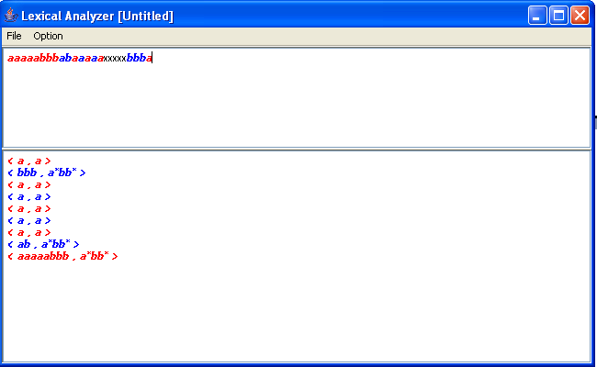

Fig. 5. Input program Screen

As shown in Fig. 5 at the upper document the user can write his programs, recognized tokens are detected automatically, they are highlighted by either red or blue, and show at the lower document the recognized token and its attribute value in the form <token, attribute value>. The unrecognized tokens will be at black.

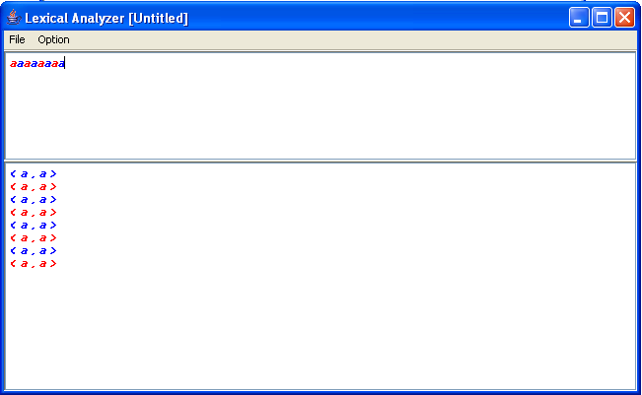

Fig. 6. The output after writing "aaaaaaaa"

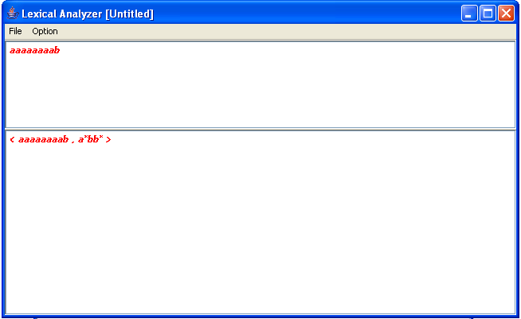

Fig. 7. The output after adding "b" to the previous example

Deterministic Finite State Acceptor

From "Option" select "Show DFSA"
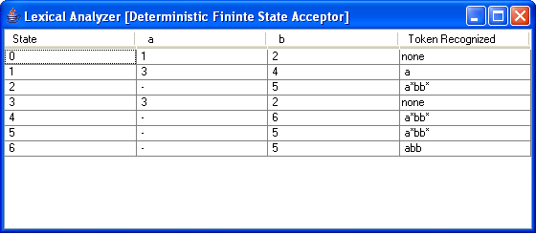
Fig. 8. Deterministic Finite State Acceptor

Minimum groups
From "Option" select "Show MFSA"

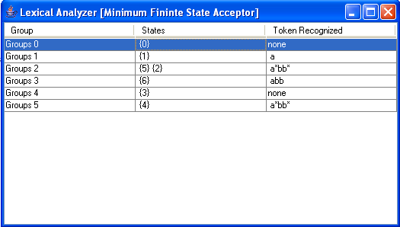
Fig. 9. Minimum Groups

Sample Run:

Use the regular definitions describing the set of tokens in the subset of PASCAL, and then apply the following program:

program example(input,output);
var x, y: integer;
function gcd(a, b: integer): integer;
begin
if b = 0 then gcd := a
else gcd := gcd(b, a mod b)
end;

begin
read (x, y);
write (gcd(x, y))
end.

Pascal Productions

program → program “token”
var → var “token”
array → array “token”
of → of “token”
integer → integer “Non token”
real → real “Non token”
standard_type → integer | real “token”
function → function “token”
procedure → procedure “token”
begin → begin “token”
end → end “token”
if → if “token”
then → then “token”
else → else “token”
while → while “token”
do → do “token”
not → not “token”
relop → = | <> | < | <= | >= | > “token”
addop → + | - | or “token”
mulop → * | / | div | mod | and “token”
assignop → := “token”
delimop → . | .. | : | , | ; | ( | ) | [ | ] “token”
letter → a|b|..|z|A|B..|Z “Non token”
digit → 0|1|2|3|4|5|6|7|8|9 “Non token”
letter|digit → letter | digit “Non token”
id → letter ( letter | digit )* “token”
digits →digit digit* “Non token”
fraction → .digits “Non token”
optional_fraction → fraction | Є “Non token”
sign → + | - “Non token”
optional_sign → sign | Є “Non token”
exponent → E optional_sign digits “Non token”
optional_exponent → exponent | Є “Non token”
num → digits optional_fraction optional_exponent “token”

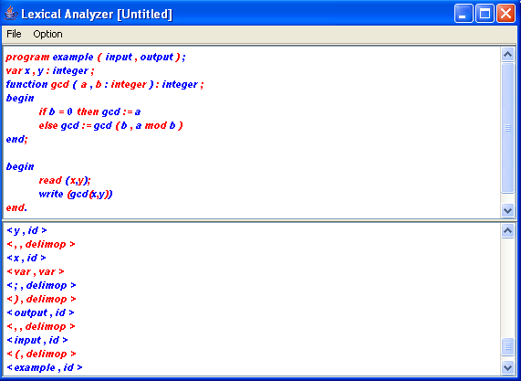

Fig. 10. The output using pascal's program

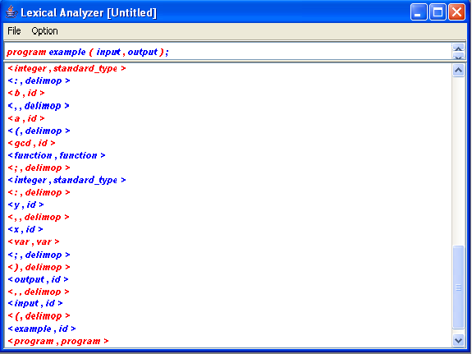

Fig. 11. Zooming on the output

